DCO-004 Updates Needed

Link:
https://humanservices.arkansas.gov/divisions-shared-services/county-operations/health-care-programs/
Capture:
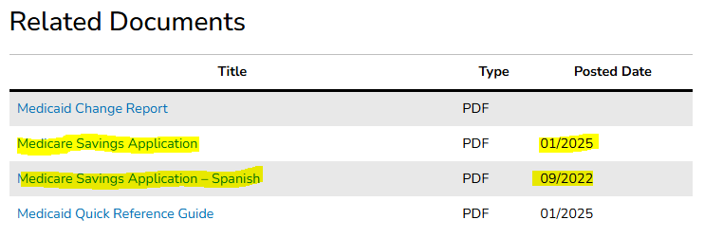

Link:
https://humanservices.arkansas.gov/divisions-shared-services/medical-services/healthcare-programs/tefra/how-to-apply-for-tefra-coverage/
Capture:
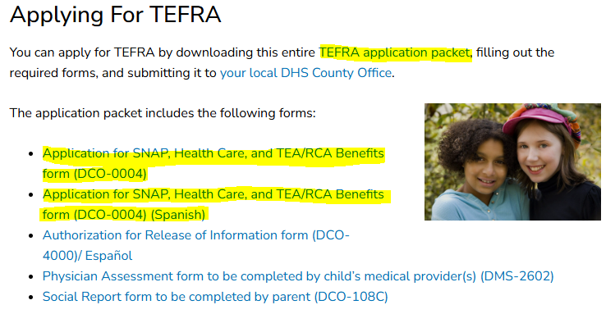

Link:
https://humanservices.arkansas.gov/divisions-shared-services/county-operations/temporary-assistance-for-needy-families/transitional-employment-assistance-tea-work-pays/
Capture:

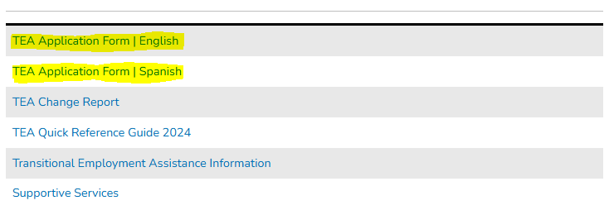
Link:
https://humanservices.arkansas.gov/divisions-shared-services/county-operations/supplemental-nutrition-assistance-snap/

