**Arkansas**

**Prevention Services Directory**

**FFY 2025/2026**

**REGIONAL PREVENTION PROVIDERS (RPP)**

**REGIONAL MAP**

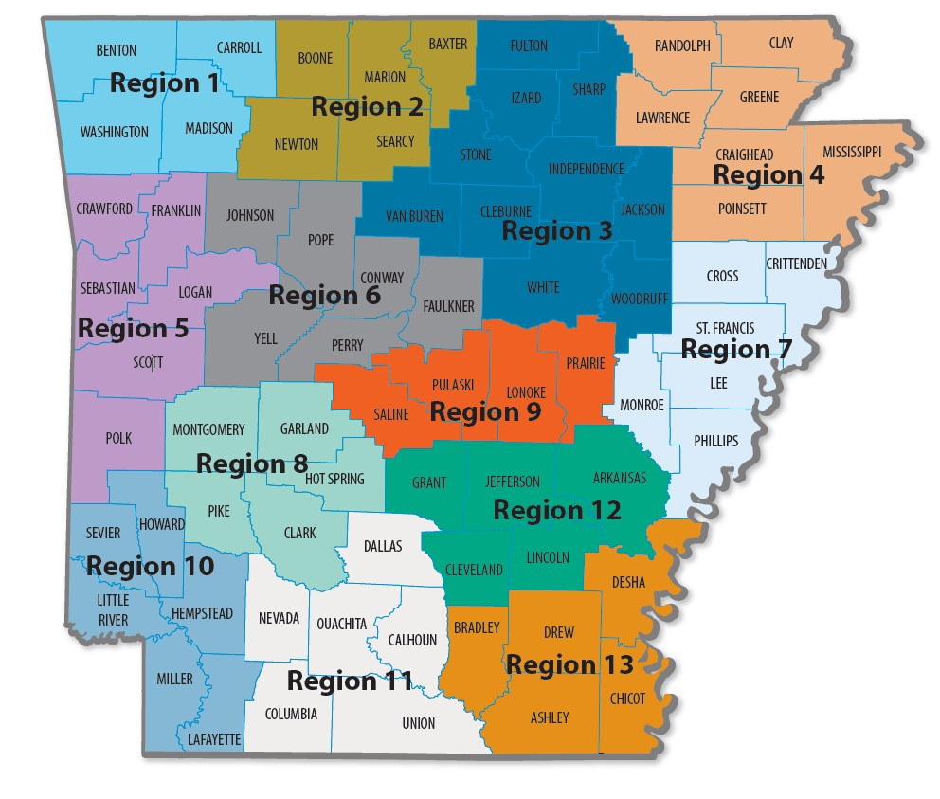

**Arkansas Department of Human Services**

**Office of Substance Abuse and Mental Health (OSAMH) Prevention Staff**

|  |  |  |  |
| --- | --- | --- | --- |
| **DHS/OSAMH**  700 Main Street  South, Slot 173  Little Rock, AR 72203 | Joycelyn Pettus  Deputy Director | Joycelyn.Pettus@dhs.arkansas.gov | Office: (501) 686-9921  Cell: (501) 218-6885 |
| Cody Conway  Collegiate Program Coordinator | [Cody.Conway@dhs.arkansas.gov](mailto:Cody.Conway@dhs.arkansas.gov) | Cell: (501) 744-8236 |

**MidSOUTH Prevention Staff**

|  |  |  |  |
| --- | --- | --- | --- |
| **UALR/MidSOUTH** 2801 South University Avenue Reynolds Bldg., 4th Floor  Little Rock, AR 72204  Fax: (501) 569-3364 | Jessica Simpson | jlsimpson@midsouth.ualr.edu | (501) 451-9218 |
| Darla Kelsay | djkelsay@midsouth.ualr.edu | (501) 951-8959 |
| Austin Blue | ajblue@midsouth.ualr.edu | (501) 690-6134 |
| Paul Blanchard | pdblanchard@midsouth.ualr.edu | (501) 859-0363 |
| Matthew Kirchner | mjkirchner@midsouth.ualr.edu | (501) 831-9235 |
| Doris Resimont | [ddresimont@midsouth.ualr.edu](mailto:ddresimont@midsouth.ualr.edu) | (501) 539-2752 |
| Tina Paxton | [tmpaxton@midsouth.ualr.edu](mailto:tmpaxton@midsouth.ualr.edu) | (501) 529-4936 |
| Greg Smith | [gksmith@midsouth.ualr.edu](mailto:gksmith@midsouth.ualr.edu) | (501) 804-7187 |
|  |

**Regional Prevention Provider (RPP) Information**

|  |  |  |  |  |  |
| --- | --- | --- | --- | --- | --- |
| **Region Numbers and Counties** | **Regional**  **Prevention**  **Provider (RPP)** | **Regional**  **Prevention**  **Representative (RPR)** | **RPR Email Address** | **RPR Phone Numbers Fax Numbers** | **RPP Addresses** |
| 4  **Region 1**  Benton, Carroll,  Madison, and  Washington Counties | Community Clinic NWA | Gwen Kuhns | [Gweneth.kuhns@ccnwa.org](mailto:Gweneth.kuhns@ccnwa.org) | (479) 751-7417 ext. 6187  Deb: (479) 751-7417 ext. | 800 E Emma Ave.  Springdale AR 72764 |
| Deb Crawford | deb.crawford@communityclinicnwa.org |
| **Region 2** 5  Baxter, Boone, Marion,  Newton, and Searcy Counties | North Arkansas  Partnership for  Health Education | Kyle Evatt | kyle.evatt@northark.edu | Office:  (870) 365-6518 Fax:  (870) 391-3507 | 825 N Main St, Ste 7  303 N. Main Street, Suites 102 & 104  Harrison, AR 72601 |
| **Region 3** 10  Cleburne, Fulton,  Independence, Izard,  Jackson, Sharp, Stone,  Van Buren, White, and Woodruff Counties | Crowley's Ridge Development Council, Inc. | Kim Sims | ksmims@crdcnea.com | Kim:  (870) 819-6970 Barbara:  (870) 819-6885  Stacy:  (870) 520-0713 | 1708 E Main St Mountain View, AR 72560 |
| Barbara Hacker | bhacker@crdcnea.com |
| Stacy Taylor | staylor@crdcnea.com | 2485 Harrison Street, Suite 5, Batesville, AR 72501 |
| **Region 4** 7  Clay, Craighead,  Greene, Lawrence,  Mississippi, Poinsett, and Randolph Counties | Research Solutions, Inc. | Lisa Perry | lisa@researchsolutionsinc.org | Office:  (870) 520-0073 | 2224 Conrad  Jonesboro, AR 72401 |
| Sossity Lewis | [slewis@researchsolutionsinc.org](mailto:slewis@researchsolutionsinc.org) | (870) 790-0331 |
| Chip Carroll | [rhcarroll@researchsolutionsinc.org](mailto:rhcarroll@researchsolutionsinc.org) | (870) 275-7989 |
| Henry Burrell | [hburrell@researchsolutionsinc.org](mailto:hburrell@researchsolutionsinc.org) | (870) 275-7989 |
| 6  **Region 5**  Crawford, Franklin,  Logan, Polk, Scott, and Sebastian Counties | Harbor House, Inc. | Jadyn McGrew | jketter@recoveryhhi.org | Office:  (479) 259-5549  Fax:  (479) 783-1914 | 3900 Armour Avenue Fort Smith, AR, 72904 |
| Katherine Chitwood | [kmeador@harborhouse.inc](mailto:kmeador@harborhouse.inc) |
| Katie Preist | kpriest@harborhouse.inc |
| 6 **Region 6**  Conway, Faulkner,  Johnson, Perry, Pope, and Yell Counties | Conway County  Community Service, Inc. | Amy Mellick-Wetzel | [amellick@csiyouth.com](mailto:amellick@csiyouth.com) | Office:  (479) 967-3370  Fax:  (479) 967-2775  Shannon:  (501) 354-4589 | 1505 South Oswego Ave Russellville, AR, 72802  Shannon:  100 S. Cherokee  Morrilton, AR 72110 |
| Sam Taylor | [staylor@csiyouth.com](mailto:staylor@csiyouth.com) |
| Shannon Cook | [scook@csiyouth.com](mailto:scook@csiyouth.com) |
| **Region 7**  Crittendon, Cross, Lee,  Monroe, Phillips, and  St. Francis Counties | Crowley's Ridge Development Council, Inc. | Kendon Gray | kendon@crdcnea.com | Kendon:  (870) 821-1707  Office:  (870) 298-2250  Fax:  (870) 298-2249 | 593 Highway 243  Marianna, AR, 72360 |
| Genaie Wilkins | [gwilkins@crdcnea.com](mailto:gwilkins@crdcnea.com) |
| **Region 8** 5  Clark, Garland, Hot  Springs, Montgomery, and Pike Counties | Ouachita Children, Youth & Family Services | Bailey Sharver | [bsharver@occnet.org](mailto:bsharver@occnet.org) | Office: (501) 915-4050  Fax: (501) 623-4226 | 1401 Malvern Avenue, Suite 22  Hot Springs, AR 71901 |
| 4  **Region 9**  Lonoke, Prairie,  Pulaski, and Saline Counties | Family Service Agency, Inc. | Hayse Miller | hmiller@fsainc.org | Office: (501) 372-4242  Ext. 752  Fax: (501) 372-4758 | 628 West Broadway Street  Suite 201  North Little Rock, AR, 72114 |
| Genine Perez | gperez@fsainc.org | Office: (501) 372-4242  Ext. 753  Fax: (501) 372-4758 |
| **Region 10** 6  Hempstead, Howard,  Lafayette, Little River,  Miller, and Sevier Counties | Bridging the Gaps of Arkansas | Johnny Riley | johnnyrileyjr@gmail.com | (903) 908-5763 | 209 E 14th Street  Texarkana, AR, 71854 |
| Crystal Ball | [Crystal.ball@btgarkansas.org](mailto:Crystal.ball@btgarkansas.org) |
| 6 **Region 11**  Calhoun, Columbia,  Dallas, Nevada,  Ouachita, and Union Counties | Bridging the Gaps of Arkansas | Barbara Riley | [Bpitts9@aol.com](mailto:Bpitts9@aol.com) | (903) 908-9754 | 209 E 14th Street  Texarkana, AR 71854 |
| Lititia Reynolds-Rankins | [Lititia.reynolds@btgarkansas.org](mailto:Lititia.reynolds@btgarkansas.org) | (903) 908-9754 |
| Johnny Riley | [johnny@btgarkansas.org](mailto:johnny@btgarkansas.org) | (903) 908-5763 |
| 5 **Region 12**  Arkansas, Cleveland,  Grant, Jefferson, and Lincoln Counties | Community  Empowerment  Council, Inc. | Tanishia Lewis | tanishialewis@cecemp.org | Phone: (870) 534-2047  Fax: (870) 534-2036 | 4701 Dollarway Rd  Pine Bluff, AR 71601 |
| Alexis Anderson | aanderson@cecemp.org |
| 5  **Region 13**  Ashley, Bradley,  Chicot, Desha, and Drew Counties | Phoenix Youth and Family Services | Roshunda Davis-Johnson | rdavis@phoenixyouth.com | Office: (870) 364-1676  (870)364-1684 ext. 203  Fax: (870) 364-1779 | 310 North Alabama Street Crossett, AR, 71635 |
| Arnetta Pugh | [apugh@phoenixyouth.com](mailto:apugh@phoenixyouth.com) |
| Evelyn Prosper | [eprosper@phoenixyouth.com](mailto:eprosper@phoenixyouth.com) |
| Christie Lindsay | clindsay@phoenixyouth.com |

**PARTNERSHIPS for SUCCESS (PFS) REGIONAL PROVIDER MAP**

**Partnerships for Success (PFS)**

**Prevention Partner Information**

|  |  |  |  |  |  |
| --- | --- | --- | --- | --- | --- |
| **Region Numbers and Counties** | **Prevention Partner Agency** | **Prevention Partner Representative** | **Prevention Partner Email Address** | **Prevention Partner Phone Number** | **Prevention Agency Address** |
| **Region 1**  Baxter, Benton, Boone, Carroll, Conway, Faulkner, Johnson, Madison, Marion, Newton, Perry, Pope, Searcy, Yell, Washington | Community Clinic | Mariela Martinez | [Mariela.Martinez@ccnwa.org](mailto:Mariela.Martinez@ccnwa.org) | Office: (479) 751-7414 | 614 E. Emma Ave, Suite 300  Springdale, AR 72764 |
| Christopher White | [cwhite@communityclinicnwa.org](mailto:cwhite@communityclinicnwa.org) |
| **Region 2**  Clay, Cleburne, Craighead, Crittenden, Cross, Fulton, Greene, Independence, Izard, Jackson, Lawrence, Lee, Mississippi, Monroe, Phillips, Poinsett, Randolph, Sharp, Stone, St. Francis, White, Woodruff, Van Buren | Crowley’s Ridge Development Council | Zatiece Fraction | [ZFraction@crdcnea.com](mailto:ZFraction@crdcnea.com) | Office: (870) 298-2249 | 593 State Hwy 243  Marianna, AR 72360 |
| Kendon Gray | [Kendon@crdcnea.com](mailto:Kendon@crdcnea.com) | (870) 821-1707 |
| **Region 3**  Calhoun, Columbia, Crawford, Dallas, Franklin, Hempstead, Howard, Lafayette, Little River, Logan, Miller, Nevada, Ouachita, Polk, Scott, Sebastian, Sevier | Bridging the Gaps of Arkansas | Johnny Riley | [JohnnyRileyJr@gmail.com](mailto:JohnnyRileyJr@gmail.com) | (903) 908-5763 | 4425 Jefferson Ave, Suite B  Texarkana, AR 71854 |
| Barbra Riley | [Barbara.Riley@btgarkansas.org](mailto:Barbara.Riley@btgarkansas.org) | (903) 908-5754 |
| **Region 4**  Arkansas, Ashley, Bradley, Chicot, Cleveland, Desha, Drew, Grant, Jefferson, Lincoln | Community Empowerment Council | Tempest Alexander | [Region12PFSTCAlexander@gmail.com](mailto:Region12PFSTCAlexander@gmail.com) | 870-534-2047 | 4701 Dollarway Rd  Pine Bluff, AR 71601 |
| Alexis Anderson | [AAnderson@cecemp.org](mailto:AAnderson@cecemp.org) |
| **Region 5**  Clark, Garland, Hot Spring, Lonoke, Montgomery, Pike, Prairie, Pulaski, Saline | Center for Healing Hearts and Spirits | Shem Ngwira | [Shem.CHHS@gmail.com](mailto:Shem.CHHS@gmail.com) | Office: (501) 372-3800 | 2416 Chester Street  Little Rock, AR 72206 |
| Joyce Raynor | [JMRaynor22@gmail.com](mailto:JMRaynor22@gmail.com) | 501-352-4325 |

**Arkansas Collegiate Network**

|  |  |  |  |  |
| --- | --- | --- | --- | --- |
| **ACN College/University** | **ACN College/University Address** | **ACN Contact Name**  **(Grey font = not yet verified)** | **ACN Contact Email** | **ACN Contact Phone Number** |
| **Cossatot Community College of the University of Arkansas** | 183 College Drive  De Queen, AR 71832  (870)584-4471  (800)844-4471 | Erika Buenrrostro | ebuenrrostro@cccua.edu | (870) 784-5154 |
| Alisa Cooke | acooke@cccua.edu |  |
| Beverly Litchford | blitchford@cccua.edu |  |
| **University of Central Arkansas** | 201 Donaghey Ave  Conway, AR 72035  (501) 450-5000 | Dr. Stephanie Rose | srose3@uca.edu | (501) 852-0260 |
| **University of Arkansas at Pine Bluff** | 200 North University Dr.  **Pine Bluff,** AR 71601 (870)575-8000 | Dr. Cynthia Troutman | troutmanc@uapb.edu | (870) 575-8716 |
| Dr. Cheryl D. Jackson-Golden | jacksongoldenc@uapb.edu | (870) 575-8073 |
| Ralph Owens, Dean of Students | owensr@uapb.edu |  |
| **Arkansas Baptist College** | 1600 Dr. Martin Luther King, Jr.**Dr.**  **Little Rock, AR** 72202 (501)420-1200 | Dr. Vicki Williams | vicki.williams@arkansasbaptist.edu | (501) 353-7188 |
| **Hendrix College** | 1600 Washington Ave.  Conway, AR 72032  (501) 329-6811 | Mary Anne Seibert | seibert@hendrix.edu |  |
| **Harding University** | 915 E. Market Ave.  Searcy, AR 72149  501-279-4000 | Jeanie Smith | jsmith17@harding.edu | 501-279-5528 |
| **Southeast Arkansas College** | 1900 S Hazel St,  Pine Bluff, AR 71603  (870) 543-5900 | Greg Myles | gmyles@seark.edu | 210-885-5658 |
| **Northwest Arkansas Community College** | 1 College Dr.  Bentonville, AR 72712  (479) 636-9222 | Becky Hudson | rhudson1@nwacc.edu | (479) 986-6682 |
| Tyler Thompson | tyjesst24@icloud.com | (479) 321-9881 |
| Ethan Reese-Whiting | ereesewhiting@nwacc.edu |  |
| **University of Arkansas at Little Rock** | 2801 South University Ave.  Little Rock, AR 72204 (501)916.3000 | Sharon Downs  Assistant Vice Chancellor - Wellness and Inclusion | sadowns@ualr.edu | (501) 916-5523 |
| Dr. Aresh Assadi  Director of Counseling Services | axassadi@ualr.edu | (501) 916-3185 |
| Hyginus Ukadike, MPA, MSW | hiukadike@ualr.edu | (501) 916-3185 |
| **Philander Smith College** | 900 W Daisy Bates Dr.  Little Rock, AR 72202  (501) 375-9845 | Dr. Rhonda Lovelace, Ed.D. | rlovelace@philander.edu | (501) 370-5297 |
| **Shorter College** | 604 N Locust St,  North Little Rock, AR  72114 | Dr. Yvette Wimberly | mattie.wimberly@shortercollege.edu | (501) 374-6305 |
| Dr. Formon Thompson | [formon.thompson@shortercollege.edu](mailto:formon.thompson@shortercollege.edu) | (501) 374-6305 |
| **Arkansas Tech College** | 105 West O Street. Russellville,**AR** 72801  (479) 968-0343 | Hunter Bramlitt, LPC | jbramlitt@atu.edu | (479) 968-0329 |
| **University of Arkansas-**  **Pulaski Technical College** | 3000 West Scenic Dr.  North Little Rock, AR 72118  (501) 812-2200 | Michelle Anderson, Associate Dean of Students | manderson@uaptc.edu | (501) 812-2756 |
| Dean Joshua Engle | [jengle@uaptc.edu](mailto:jengle@uaptc.edu) | (501) 812-2211 |
| **Southern Arkansas University** | 100 E. University  Magnolia, **AR** 71753  (870) 235-4000 | Carey Baker | careybaker@saumag.edu | (870) 235-4041 |
| Kandice Herron,  Associate Dean for Parent and Student Engagement | [klherron@saumag.edu](mailto:klherron@saumag.edu) |  |
| **National Park College** | 101 College Dr.  Hot Springs, AR 71913  (501)760-4222 | Susan Millerd, LCSW | smillerd@np.edu | (501) 760-4163 |
| Dr. Jerry W. Thomas | jerry.thomas@np.edu |  |
| **Arkansas State University - Newport** | 7648 Victory Blvd.  Newport, AR 72112  (870) 512-7800 | Samantha Harris  (Primary Contact) | samantha_harris@asun.edu |  |
| Betsy Walker  (Alternate) | betsy_walker@asun.edu | (870) 680-8737 |
| **University of Arkansas** |  | Sarah Werner | sarah.werner@communityclinicnwa.org | (479) 751-7417  Ext. 6168 |
| **Arkansas State University- Jonesboro** | P.O. Box 2040  State University, AR 72467 | Dr. Mark Foster, DNP, APRN, FNP-BC  Associate Professor of Nursing, Chair of Graduate Nursing | smfoster@astate.edu | Office (870) 972-3612 |
| **Henderson State University** | 1100 Henderson St. Arkadelphia, AR 71999  (870) 230-5000 | Jonathan Campbell | campbej@hsu.edu | (870) 403-2171 |
| Dr. Verónikha Salazar | salazav@hsu.edu | (870) 230-5231 |

**Contract Contact Information**

|  |  |  |  |  |
| --- | --- | --- | --- | --- |
| **Contract Agency** | **Contract Agency Address** | **Contract Contact** | **Contract Contact Email** | **Contract Contact Phone Number** |
| Arkansas Foundation for Medical Care, Inc.  (Archival Risk Factor, SYNAR) | 1020 West 4th Street  Suite 300  Little Rock, AR, 72201 | Melanie Boyd | mboyd@afmc.org | Office: (501) 212-8718  Fax: (501) 212-8782 |
| Kent Thompson | kthompson@afmc.org | Office: (501) 212-8622  Fax: (501) 212-8782 |
| International Survey  Associates, LLC. dba Pride  Surveys  (Arkansas Prevention  Needs Assessment [APNA] Survey) | 2140 Newmarket Parkway SE  Suite 116  Marietta, GA, 30067 | Melissa Stephens | melissa.stephens@isadata.com | Office: (800) 279-6361  Fax: (770) 726-9327 |
| Jay Gleaton | jay.gleaton@pridesurveys.com | Office: (800) 279-6361  Fax: (770) 726-9327 |
| University of Arkansas for Medical Sciences Center for Addiction Research  (Statewide Epidemiological  Outcomes Workgroup) | 4301 West Markham Street, Slot 843  Little Rock, AR 72205 | Alison Oliveto | [aoliveto@uams.edu](mailto:aoliveto@uams.edu) | Office: (501) 526-8441  Fax: (501) 526-7816 |
| University of Wyoming Wyoming Survey & Analysis Center | 406 S. 21st St., Laramie, WY 82070 | Rodney A. Wambeam | Rodney@uwyo.edu | Office: (307) 760-8928  Fax: (307) 766-2189 |
| University of Arkansas Little Rock  Survey Research Center (ACSUA) | 2801 S. University Ave.  Little Rock, AR 72204 | Derek Slagle | drslagle@ualr.edu | Office: (501) 569-8559 |
| End Overdose | 1055 East Colorado Blvd, #50006  Pasadena, CA 91106 | Theo Krzywicki | [Theo@endoverdose.net](mailto:Theo@endoverdose.net) | (626) 491-4900 |
| Arkansas Department of Higher Education (ADHE) | 101 E Capitol Ave  Little Rock, AR 72201 | Nick Fuller | Nick.Fuller@adhe.edu | (501) 371-2026 |
| Community Advocacy Research & Evaluation Consulting Group (CAREcg) | 4579 Laclede Ave  St. Louis, MO 63108 | Jeremy Goldbach | [JGoldbach@carecg.com](mailto:JGoldbach@carecg.com) | (832) 244-5437 |
| Kristi Allen | [Kallen@carecg.com](mailto:Kallen@carecg.com) | (281) 658-8654 |