TO: Arkansas Medicaid Health Care Providers – Inpatient Psychiatric Services for Under Age 21

EFFECTIVE DATE: June 20, 2025

SUBJECT: Provider Manual Update Transmittal INPPSYCH-1-25

|  |  |  |  |
| --- | --- | --- | --- |
| **REMOVE** | | **INSERT** | |
| **Section** | **Effective Date** | **Section** | **Effective Date** |
| 201.000 | 8-15-05 | 201.000 | 6-20-25 |
| 202.200 | 7-1-17 | — | — |
| 203.000 | 10-14-16 | — | — |
| 211.000 | 7-1-17 | 211.000 | 6-20-25 |
| 212.100 | 10-1-17 | 212.100 | 6-20-25 |
| 213.000 | 10-13-03 | — | — |
| 213.100 | 7-1-20 | — | — |
| 213.200 | 8-15-05 | — | — |
| 213.300 | 10-13-03 | — | — |
| 215.400 | 10-13-03 | — | — |
| 220.400 | 10-13-03 | — | — |
| 221.800 | 8-15-05 | — | — |
| 221.801 | 7-1-17 | — | — |
| 221.802 | 10-1-17 | — | — |
| 221.803 | 10-1-17 | — | — |
| 221.804 | 10-1-17 | — | — |
| 230.010 | 10-14-16 | 230.010 | 6-20-25 |
| 241.000 | 12-1-13 | 241.000 | 6-20-25 |
| 241.500 | 12-1-13 | — | — |
| 242.000 | 10-14-16 | 242.000 | 6-20-25 |
| 250.300 | 7-1-04 | 250.300 | 6-20-25 |
| 250.400 | 7-1-04 | — | — |

Explanation of Updates

The Inpatient Psychiatric Services for Under Age 21 provider manual has been divided into two manuals. Policy for the new Psychiatric Residential Treatment Facility Services provider manual has been removed from this text.

Section 201.000 is edited to remove “facility based.”

Sections 202.200 and 203.000 are removed.

Section 211.000 is edited to remove independent assessment information, methods of referral, and examples of priority populations.

Section 212.100 is modified to remove “residential treatment center” and “sexual offender program.”

Section 213.000, 213.100, 213.200, 213.300, 215.400, 220.400, 221.800, 221.801, 221.802, 221.803, and 221.804 are removed.

Section 230.010 is changed to require prior authorization (PA) for residential unit services and to name the patient’s PASSE responsible for acquiring the PA.

Section 241.000 is modified to remove “residential.”

Section 241.500 is removed.

Section 242.000 is edited to remove “residential” and name the beneficiary’s PASSE responsible for completing reviews of residential unit services.

Section 250.300 is renamed “Suggested Budget Format.”

Section 250.400 is removed.

This update transmittal memorandum indicates which sections of your provider manual have been revised. Electronic versions of provider manuals available from the Arkansas Medicaid website have changes incorporated. See Section I for instructions on updating a paper copy of the manual.

If you have questions regarding this transmittal, please contact the Provider Assistance Center at  
(800) 457-4454 toll-free or locally at (501) 376-2211.

If you need this material in an alternative format, such as large print, please contact the Office of Policy and Rules at (501) 320-6428.

Arkansas Medicaid provider manuals (including update transmittals), official notices, notices of rule making, and remittance advice (RA) messages are available for downloading from the [Division of Medical Services website](https://humanservices.arkansas.gov/divisions-shared-services/medical-services/helpful-information-for-providers/manuals/).

Thank you for your participation in the Arkansas Medicaid Program.

Elizabeth Pitman

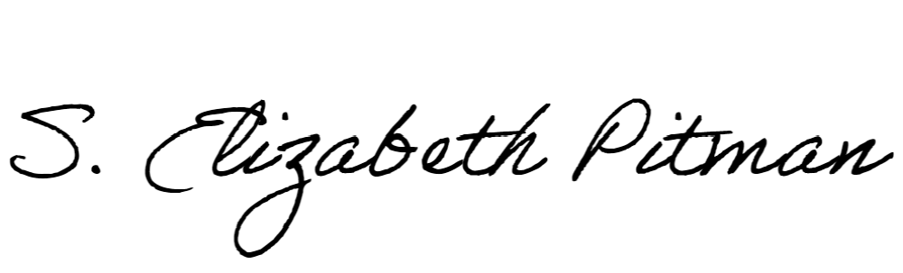

Director