TO: Arkansas Medicaid Health Care Providers – Nurse Practitioner

EFFECTIVE DATE: July 1, 2025

SUBJECT: Provider Manual Update Transmittal NURSEPRA-1-25

|  |  |  |  |
| --- | --- | --- | --- |
| **REMOVE** | | **INSERT** | |
| **Section** | **Effective Date** | **Section** | **Effective Date** |
| 214.600 | 1-1-23 | 214.600 | 7-1-25 |

Explanation of Updates

Section 214.600 is updated to include limited outpatient obstetrical services only for Presumptive Eligibility Pregnant Women (Category 62).

This update transmittal memorandum indicates which sections of your provider manual have been revised. Electronic versions of provider manuals available from the Arkansas Medicaid website have changes incorporated. See Section I for instructions on updating a paper copy of the manual.

If you have questions regarding this transmittal, please contact the Provider Assistance Center at  
(800) 457-4454 toll-free or locally at (501) 376-2211.

If you need this material in an alternative format, such as large print, please contact the Office of Policy and Rules at (501) 320-6428.

Arkansas Medicaid provider manuals (including update transmittals), official notices, notices of rule making, and remittance advice (RA) messages are available for downloading from the [Division of Medical Services website](https://humanservices.arkansas.gov/divisions-shared-services/medical-services/helpful-information-for-providers/manuals/).

Thank you for your participation in the Arkansas Medicaid Program.

Elizabeth Pitman

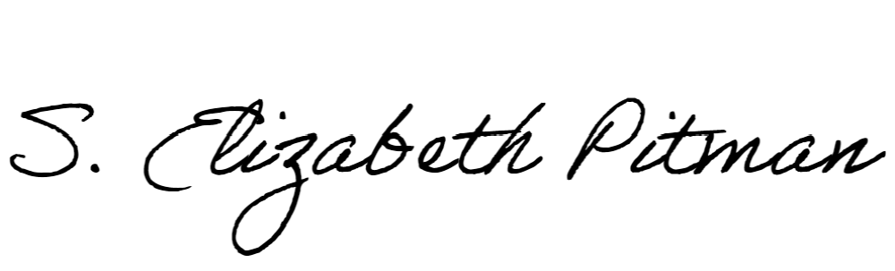

Director